**Department of Electrical and Computer Engineering**

**University of Thessaly**

**Game Architecture and Development**

Zafeiri Stamatia Varvara

**Stars**

***Game Design Document***

Table of Content  
Introduction ...................................................................................................... 3  
1 Game Concept................................................................................................ 4  
 1.1 Idea............................................................................................................ 4  
 1.2 Goal........................................................................................................... 4  
 1.3 Player’s role............................................................................................... 4  
 1.4 Main gameplay mode................................................................................ 4  
 1.5 Genre......................................................................................................... 4  
 1.6 Target Audience........................................................................................ 5  
 1.7 Interaction Mode...................................................................................... 5  
 1.8 Camera Model........................................................................................... 5  
 1.9 Hardware Platform.................................................................................... 5  
 1.10 Game World............................................................................................ 5  
 1.11 Unique value........................................................................................... 6  
2 Gameplay........................................................................................................ 7  
 2.1 Hierarchy of challenges............................................................................. 7  
 2.2 Actions....................................................................................................... 9  
3 Characters......................................................................................................10  
 3.1 Avatar.......................................................................................................10  
 3.2 NPS’s........................................................................................................10  
4 Story.............................................................................................................. 11  
5 Core Mechanics............................................................................................. 12  
 5.1 Structure of the game............................................................................. 12  
 5.2 Game Objects.......................................................................................... 12  
 5.3 Game Events........................................................................................... 12  
 5.4 Relationships and Conditions.................................................................. 12  
6 Game world................................................................................................... 13  
 6.1 Art and style............................................................................................ 13  
 6.2 Other aspects.......................................................................................... 13  
 6.3 Places...................................................................................................... 13  
7 User Interface............................................................................................... 13  
 7.1 Menu....................................................................................................... 14  
 7.2 Main view................................................................................................ 15  
 7.3 Feedback Elements................................................................................. 15  
8 Technical parameters.................................................................................... 16  
Conclusion........................................................................................................ 17

**Introduction**

All types of games may be used in an educational environment, however educational games are games that are designed to help people learn about certain subjects, expand concepts, reinforce development, understand a historical event or culture, or assist them in learning a skill as they play.

Educational games help kids unleash their imagination and come up with creative approaches while solving problems. Hand-eye coordination involves the simultaneous use of eyes and hands during an activity. When the concept is applied to video games, children use their hands to operate a mouse, keyboard, or a mobile phone screen while they infer visual data using their eyes. Studies indicate that children who play video games grow up to perform well at jobs that require good hand-eye coordination.

Stars is an educational game for students or even adults who are interested in solar system, stars and constellations. It’s an interesting subject and usually students learn little to nothing about it in school.

Current document is Stars game specification. Specification is an artifact that is used to describe the details of the game software application. This document is divided in to two general sections: 1) game concept and 2) game specification. Game concept is a short summary of all important game aspects from game idea to its uniqueness. In game specification all those briefly mentioned aspects are described in detail.

**1 Game Concept**  
Game concept is a short summary where all important game aspects are mentioned:  
1. Main idea  
2. Game goal and learning goal  
3. Players’ role  
4. Main gameplay mode (challenges and actions)  
5. Genre  
6. Target audience  
7. Interaction mode  
8. Camera model  
9. Hardware platform  
10. Game world  
11. Uniqueness

**1.1 Idea**

Player is inside a girl’s dream (Luna’s dream) and travels from planet to planet discovering and forming constellations, learning interesting facts about them.   
  
**1.2 Goal**

Entertaining goal of the game is to unlock all planets and form all the constellations.  
Learning goal of the game is to learn constellations, where are they and interesting facts about them.  
  
**1.3 Player’s role**

Player’s role is to find each constellation and connect the stars to form it. Game is not avatar based.  
  
**1.4 Main gameplay mode**

Player’s main challenge is to form the constellations and complete the levels following Luna’s dream. Player’s main activity is pairing stars.  
  
**1.5 Genre**

Game genre is mainly educational game. It can be  
classified also as an adventure, logical and puzzle game.

**1.6 Target Audience**

1st -6th grade students – 6-12 year old students  
  
**1.7 Interaction Mode**

Single player. Player interacts with the game environment by clicking on interactive items (e.g., planets, stars). Game is not based on competition but according to players progression they will unlock new levels.

**1.8 Camera Model**

Camera is 3D straight to the game canva and does not move.  
  
**1.9 Hardware Platform**

Linux, windows, MacOS, iOS, android. Game will be accessible for download through each store or web.

**1.10 Game World**

Game environment is 3 dimensional. Game world is assembled with the help of skybox, 2 dimensional background image and 3 dimensional objects.

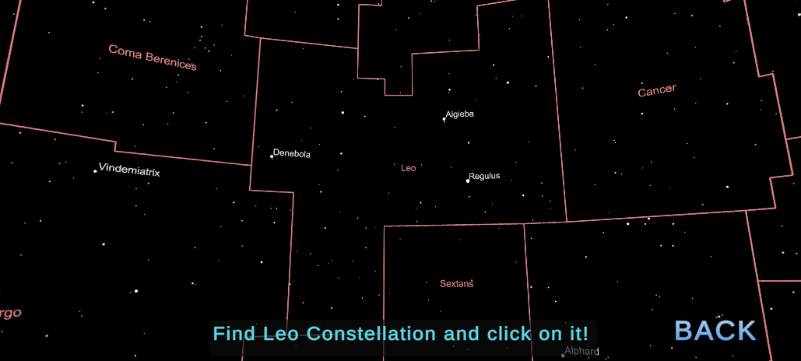

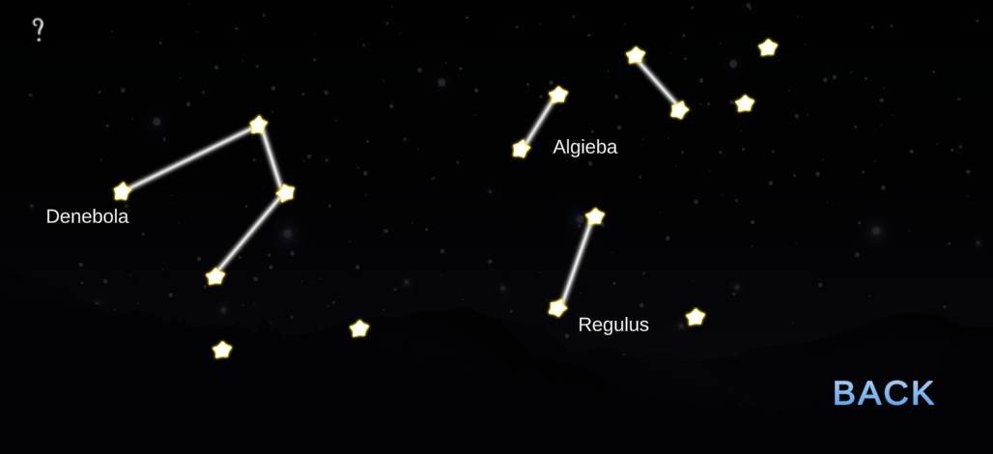

**1.11 Unique value**

Unique subject. No failure result.

**2 Gameplay**

Gameplay means challenges and actions. Gameplay is the most important element of game design. Challenges must be engaging and meaningful.  
In this game challenges belong mostly in to following categories:  
1. Exploration  
2. Solving logical puzzles – (e.g., deductive reasoning) exercises that are based on information stored in the game.  
3. Solving conceptual puzzles – exercises that are based on external information.

Exploration challenges are for example:  
1. Getting to know not familiar places   
2. Collecting hints

**2.1 Hierarchy of challenges**

The main challenge is to unlock all levels. Forming the constellations can be defined as second level challenges. Third level challenges are mainly related with exploring the skybox (sky and stars).

The hierarchy of the Stars game:  
1. Complete all levels

* 1. Mercury

1.1.1 Leo Constellation

* 1. Venus

1.2.1 Coming soon

1.2.2 Coming soon

1.2.3 Coming soon

* 1. Earth

1.3.1 Coming soon

1.3.2 Coming soon

1.3.3 Coming soon

1.3.4 Coming soon

* 1. Mars

1.4.1 Coming soon

1.4.2 Coming soon

1.4.3 Coming soon

1.4.4 Coming soon

1.4.5 Coming soon

* 1. Jupiter

1.5.1 Coming soon

1.5.2 Coming soon

1.5.3 Coming soon

1.5.4 Coming soon

1.5.5 Coming soon

1.5.6 Coming soon

* 1. Saturn

1.6.1 Coming soon

1.6.2 Coming soon

1.6.3 Coming soon

1.6.4 Coming soon

1.6.5 Coming soon

1.6.6 Coming soon

* 1. Uranus

1.7.1 Coming soon

1.7.2 Coming soon

1.7.3 Coming soon

1.7.4 Coming soon

1.7.5 Coming soon

1.7.6 Coming soon

1.7.7 Coming soon

* 1. Neptune

1.8.1 Coming soon

1.8.2 Coming soon

1.8.3 Coming soon

1.8.4 Coming soon

1.8.5 Coming soon

1.8.6 Coming soon

1.8.7 Coming soon

* 1. Pluto

1.9.1 Coming soon

1.9.2 Coming soon

1.9.3 Coming soon

1.9.4 Coming soon

1.9.5 Coming soon

1.9.6 Coming soon

1.8.7 Coming soon

1.8.8 Coming soon

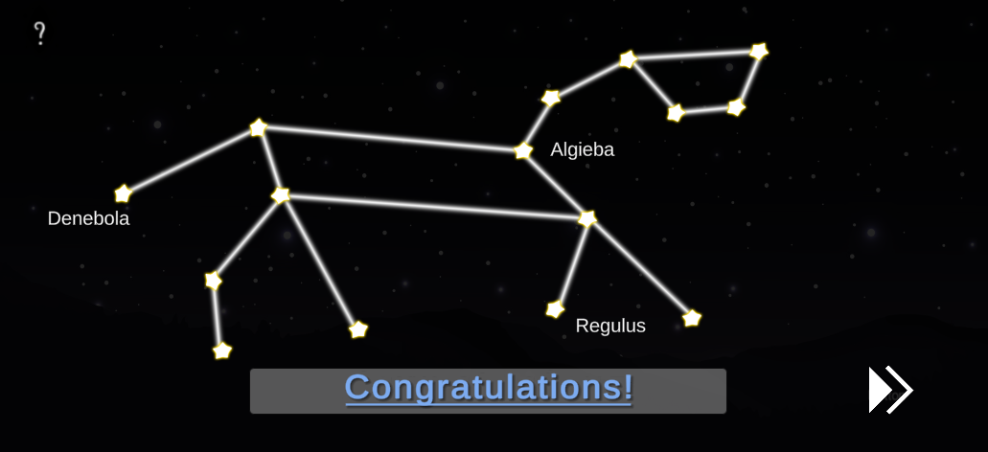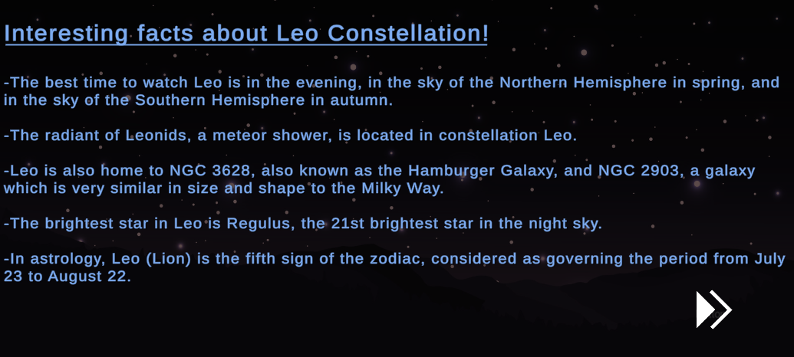

**2.2 Actions**

Actions are activities what the player can conduct in order to achieve the challenges. The number of actions is limited (same actions can be done for achieving different challenges) and depends on input devices.

Actions what the Stars player can do:  
1. Select a planet (level).

2. Navigate around stars and constellations.

3. Select and deselect stars.

All actions are performed by clicking on interactive objects with the help of mouse (also fingers and touch screen can be used).

**3 Characters**

Description of the main character (avatar) and non-player characters (Miss Smith, Luna’s mum).

**3.1 Avatar**

**Luna**

Luna has no avatar to give the opportunity to every child to imagine her the way they feal, or even be Luna.

**3.2 NPS’s**

**Miss Smith, Luna’s mum**

Same as Luna, there is no avatar neither for Miss Smith nor Luna’s mum.

**4 Story**

Today kids were discussing about the meanings of their names in class. Miss Smith told Luna that her name means moon in Latin. Later in the evening at home, at bedtime to be more specific. Luna asked her mum why she named her Luna and her mum happily responded: "You were born on a full moon and when I saw your grey eyes, I was certain that you were meant to be a Luna". As little Luna drifts to sleep she dreams about the night sky and the stars. Dreams. They feel real. But this one's not like the others. It almost feels like she's in different reality. Time to explore!

**5 Core Mechanics**  
Core mechanics describe all game objects and conditions between them - game rules.

**5.1 Structure of the game**

The game consists from 9 levels (planets). In first level we have only one constellation for the player to become familiar with the game, then every level has more and more constellations to be completed.

**5.2 Game Objects**

Game objects are all from Unity Store.

* Skybox
* Background image
* Music
* Stars
* Lines
* Planets and sun

**5.3 Game Events**

Events triggered by the player but controlled by the game.

Congratulations massage when the level is completed.

**5.4 Relationships and Conditions**

Game starts with only the Mercury level available. When a level is completed only the next is unlocked. Levels start from the planet closer to the Sun (Mercury) and unlock in order.

**6 Game world**

Game takes place in space. Each planet is a level and unlock one after the other. In the background we can see the milky-way.

**6.1 Art and style**

The solar system is based on real life and planets spin on the y axis. Stars and text are cartoon like. Also stars spin when selected on the z axis.

**6.2 Other aspects**

The game does not cause any huge emotion and does not trigger a bad feeling. There is no failure, so it’s a safe and happy environment that helps the player relax.

**6.3 Places**

The game takes place in our solar system.

**7 User Interface**

**7.1 Menu**

Menu is designed in the style of smart phone game. Menu  
options are:

- Play (game)  
- Options (sound volume)   
- Quit (game)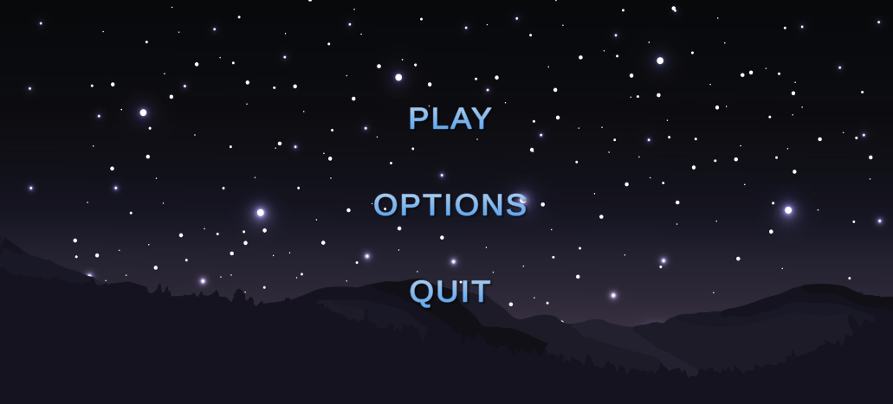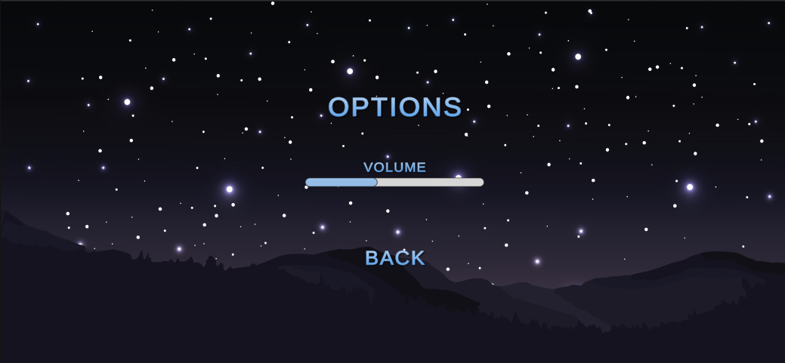

**7.2 Main view**

After choosing the option “Play” the level menu is presented.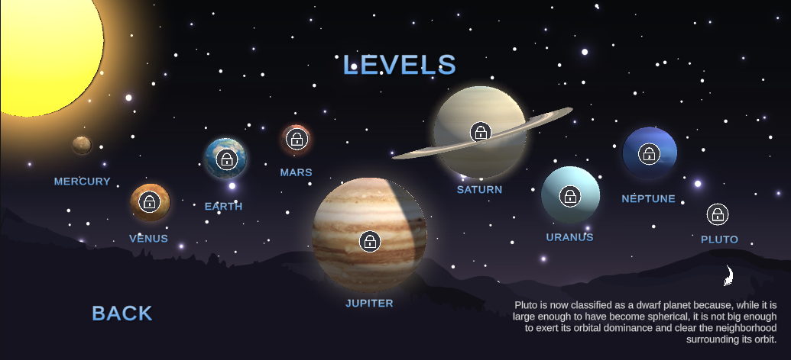

**7.3 Feedback Elements**

The player knows that if a star is spinning is selected. If two stars are spinning and there in now a line between them they are not a match.

Εικόνα που περιέχει κείμενο

Περιγραφή που δημιουργήθηκε αυτόματα

**8 Technical parameters**

OS: Linux x86_64

CPU: Intel Pentium 4

GPU: OpenGL-capable GPUs

MEMORY: 1GB RAM

HARD DRIVE: 2GB available space

**Conclusion**

Stars focuses on learning about our solar system in a fun and relaxing way. Let’s play!